The second transnational partner meeting of the European project “Rural Independent Life” was held in Aarhus, Denmark, in the 4th and 5th of October 2022
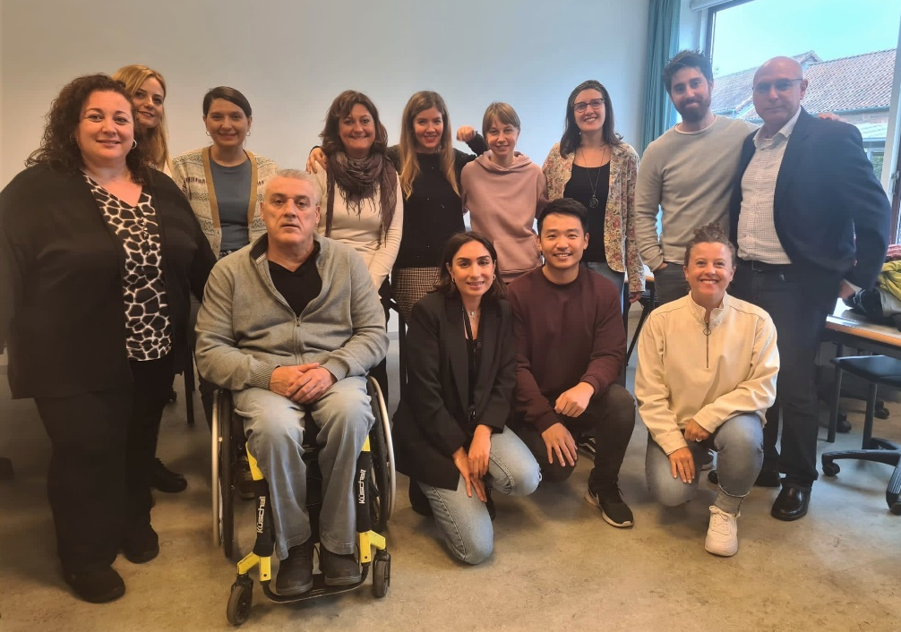
The partners of the European project “Rural Independent Life” met in Aarhus, Denmark, for their second Transnational Project Coordination Meeting.
The meeting took place in the beginning of October 2022, and it started with a presentation made by Dement, a social worker and representative of Aarhus municipality who works with youth with disabilities. She talked about the Danish service law, provided insight into how social workers work with “independent living” in Denmark, and gave some examples of interventions in rural areas. Therefore, the participant partners gained insight into the Danish system, and hopefully got some inspiration for their future work with people with disabilities.

The transnational partner meeting was a great experience for the participant partners to meet again, to consolidate their collaboration, to discuss and work on the current and future tasks, to review the project’s Gantt (timeline and project deadlines), and to conduct a mid-term evaluation for risk management.
The next Transnational Project Coordination meeting is expected to take place in March 2023, in Pianezza, Italy.

Rural In Life is co-financed by Erasmus Plus of the European Union, and also involves the entities EQUIP (Denmark), OZARA (Slovenia), Istituto dei Sordi de Torino (Italy), and Gelisim University of Istanbul (Turkey).

